


DevOps for PCF
Accelerator
June 2018

Contributors:
Kunal Parnami
Anuj Narayan
Abhishek Desai

Contents
About the accelerator 1
Developing a simple service 3
Using github as code repository 4
Build process in Jenkins 5
Deployment in PCF 9
Log draining with Paper trail 10
Issues faced during setup 11

About the accelerator
Deployment of the services to a cloud provider such as PCF, AWS, GCP manually requires human resource to take care it. By introducing CD/CI deployments to cloud can be automated without any interventions, with this accelerator we have automated build and deploy process of a microservices on PCF.

Continuous Integration and Continuous Deployment
Developing and releasing software can be a complicated process, especially as applications, teams, and deployment infrastructure grow in complexity themselves. Often, challenges become more pronounced as projects grow. To develop, test, and release software in a quick and consistent way, developers and organizations have created these related but distinct strategies to manage and automate these processes.
Continuous integration focuses on integrating work from individual developers into a main repository multiple times a day to catch integration bugs early and accelerate collaborative development. Continuous delivery is concerned with reducing friction in the deployment or release process, automating the steps required to deploy a build so that code can be released safely at any time. Continuous deployment takes this one step further by automatically deploying each time a code change is made.
Flow diagram
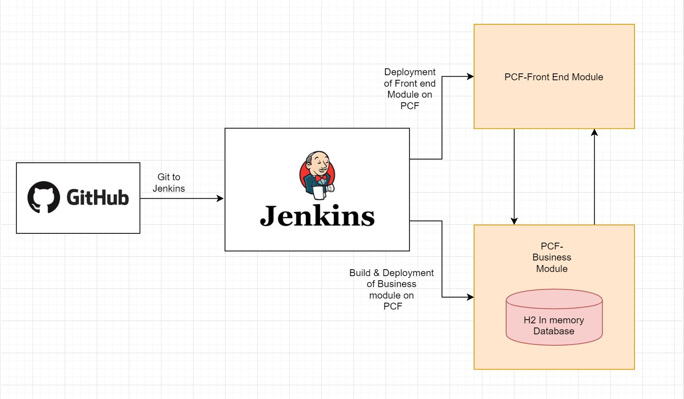

End to end solution summary
When the user commits the code into the GitHub repository, the Jenkins build is triggered. In Jenkins, we have created two tasks as Front-End Module & Business module. So, when Jenkins build happen the applications are deployed in respective PCF spaces. For managing the logs, we have bind our applications with “Paper Trail” logger. So, all are logs are logged into the Paper Trail account.

How the accelerator helps other teams to get started
This accelerator will help other teams to quickly start with CD/CI using this, normal modifications in Jenkins job as per there GIT path and server details would get them the platform implememt CD/CI with great pace.

Developing a simple service
We have developed a simple Employee Service Web Application, which consist of two parts.
- Front End Module
- Business Module

Front End Module
In this module, we have developed the front end of application using the angular 4 framework
This module mostly deals with the login and registration of new employee.

Business Module
This module consists of the business logic which needs to implement. In this module, we have created a microservice with H2 Database. This microservice exposes a end point which is mapped to angular part for execution of whole application.

Using github as code repository
We have pushed our two projects into two different git repositories.
Front End module: https://github.com/abhishekdesai321/Employee-Master-UI.git
Business module: https://github.com/AnujNarayan2319/Employee-Master

Build process in Jenkins
In Jenkins, we have developed two different jobs

The two jobs are responsible for configuration of build and deploy of microservices and angular frontend code. More on jobs configurations is mentioned below -
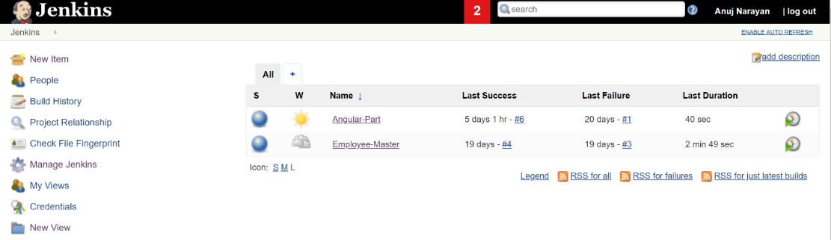

Plugins installed
Cloud Foundry plugin
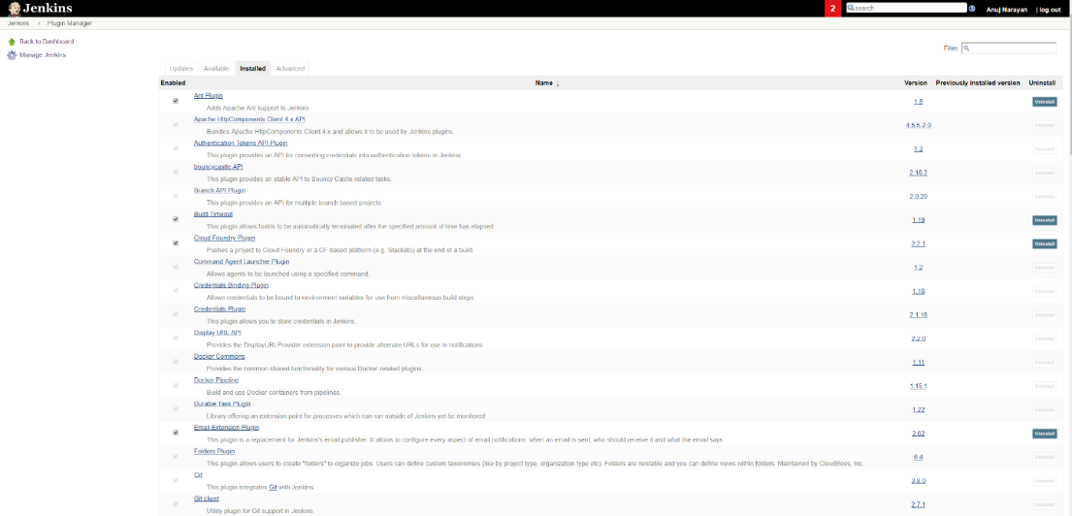

Jenkins configuration for source code management
To enable Jenkins to pull the changes from the GitHub, we need to set some configuration in Jenkins.
Firstly, we need to update the Repository URL and Credentials (User name and password for GitHub) properly. We also need to set the Branch Specific i.e. from which branch the code should be pulled.
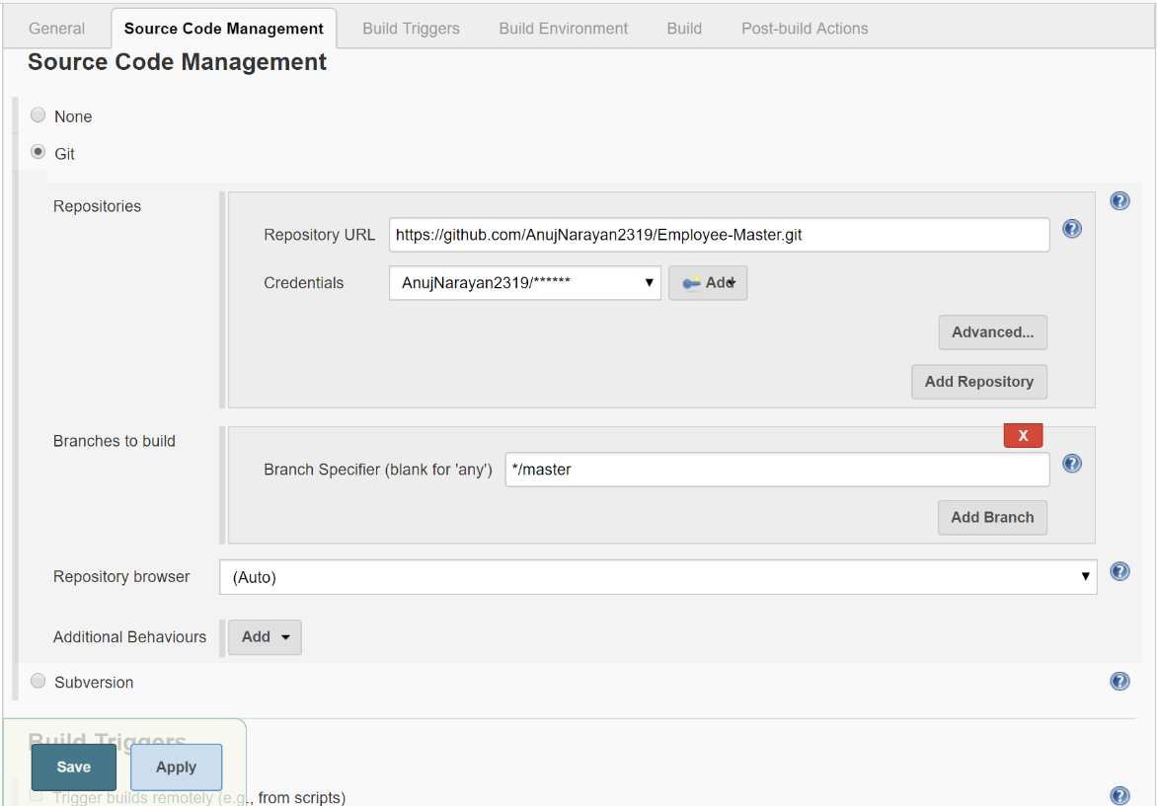

Jenkins configuration for build triggers
In Build Triggers, we have used the Poll SCM method which checks the git repository after specified internal of time for changes. If there are some changes in the code, Jenkins rebuild the project.
We have used the Schedule to check after every 1 hr. So, after every hour there is a check for changes in codes and if there are any changes Jenkins rebuild will be triggered.
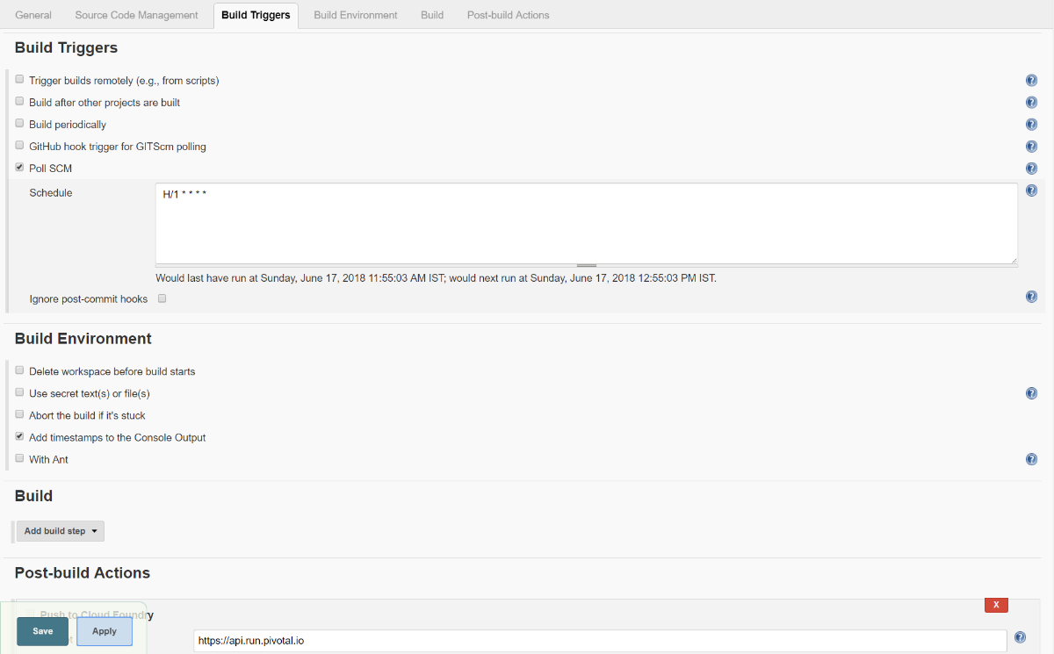

Jenkins configuration for post build actions
- Employee-Master
The manifest file for Employee-Master :
The manifest.yml includes the fields like name,instances, host, path, memory etc.
In our project Jenkins deploys the snapshot war file onto the PCF for the given path for host.

- Angular-Part
The manifest file for Angular-Part :
The manifest.yml includes the fields like name,instances, host, path, memory etc.
In our project Jenkins deploys the snapshot war file onto the PCF for the given path for host.
In post build actions, we are configuring the Jenkins to deploy the build project into PCF.
Below screenshot reflects all the configuration changes for Post Build Action.
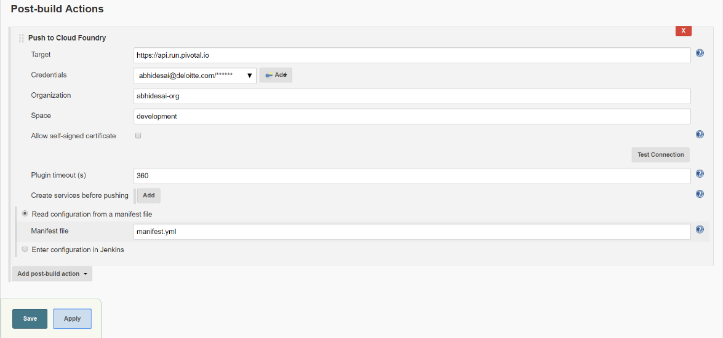
Deployment in PCF
When the Jenkins build is successful, the project is pushed onto the PCF for deployment.
As all the configuration are done in “manifest.yml” files for both project, we don’t need to explicitly deploy the project manually. The PCF will fetch all the configurations from Jenkins Post Build Action and Deploy the Projects.
The deployment in PCF is shown in below screenshots
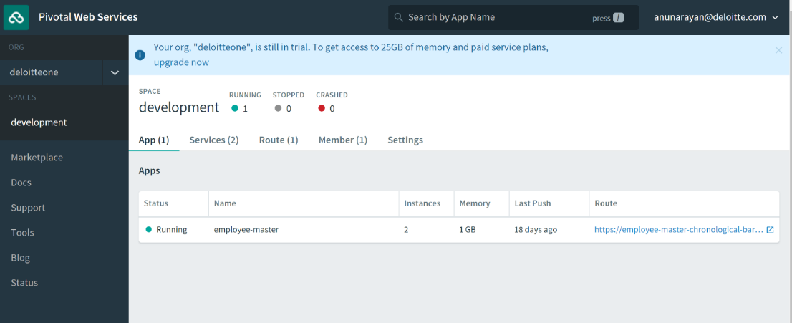
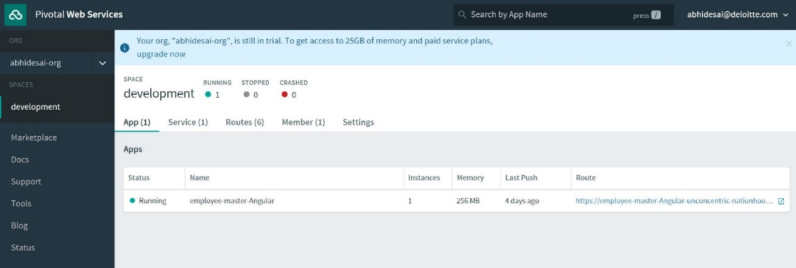

Log draining with Paper trail
For log drain, we have used the Paper trail App. Created an account on paper trail and bind our services. The following commands are used to bind the service with paper trail
cf create-user-provided-service {applicationLogDrainName} -l syslogs://{paperTrailURL}
cf bind-service {applicationName} {applicationLogDrainName}

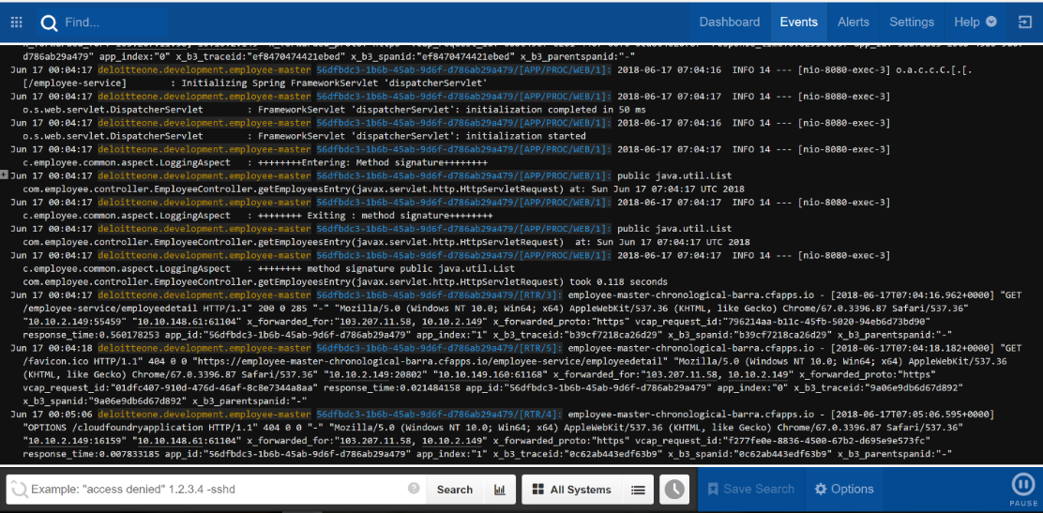
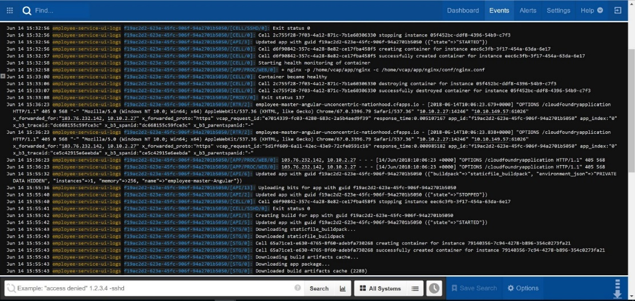
Issues faced during setup
- Problem - Jenkins was unable to detect the git.exe file path.
Solution - Configured it with exact path of GIT, in Jenkins Manage Jenkins -> Global tool configuration.
- Problem - While building the Front-End part, the build was not happening properly. It was pointing to the local URL.
Solution - To tackle with this, we have embedded the PCF-URL of Business module into the front-end Module.
- Problem - We were facing problem to keep track of the logs in PCF.
Solution - To keep track of logs in PCF, we have used Paper Trial integration with PCF for log drain.

